Use-Case Realization Report (Analysis)
View Error

Issue <1.0>
Revision History
Date | Issue | Description | Author
<29/apr/11> | <1.0> | Initial Document | Koh Ming Jin

Table of Contents
1. Brief Description 4
2. Flow of Events 4
2.1 Standard Flow 4
2.2 Exception 4
3. Interaction Diagrams 4
3.1 Collaboration Diagram for View Error 4
4. Participating Objects 4
4.1 View Error Page 4
4.2 Error Controller 4
4.3 Error 4
5. Class Diagrams 5
5.1 Domain Class Diagram: View Error 5
6. Derived Requirements 5

Use-Case Realization Report
View Error

Brief Description
This use case enables an operation manager to view an error record.

Flow of Events
The standard flow of events for this use case and any exceptions are described in the following subsections. See section 3.1 for an overview of the participating Actors and Domain Objects.

Standard Flow
The flow of events is described as follows:

- The use case starts when Operation Manager selects the View Error option of the system.
- The View Error Page, which includes all the error details, is displayed.
- The use case terminates.

Exception
- NIL

Interaction Diagrams

Collaboration Diagram for View Error
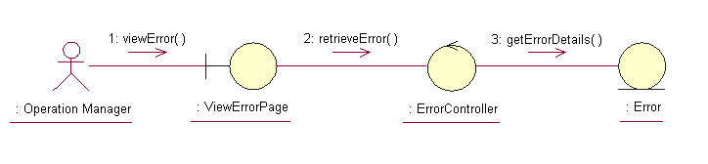

Participating Objects

View Error Page
This object renders the contents to allow authorized actors to view Error information. The Director, Department Manager and Operation Manager actors use this object.

Error Controller
This object acts as the middleman between “View Error” Page and the Error object. It will translate interactions with the view into actions to be performed by the Error object.

Error
This object stores the details concerning the error of the COMS.

Class Diagrams

Domain Class Diagram: View Error
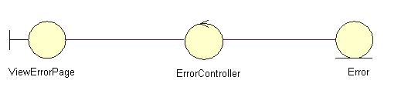

Derived Requirements
The Operation Manager PC keyboard and mouse will be used to retrieve error details (if any) and view all the system responses.

